Tugas Evaluasi Praktikum VIII Makassar, 15 Mei 2024

**PRAKTIKUM**

**ALGORITMA & PEMROGRAMAN 2**



Nama : Andi Ikhlas Mallomo

Stambuk : 13020230251

Frekuensi : TI_ALPRO 2–7 (A7)

Dosen : Ramdaniah, S.Kom., M.T., MTA

Asisten 1 : Aulia Putri Utami, S.Kom., MTA., MCF

Asisten 2 : Athar Fathana Rakasyah

**PROGRAM STUDI TEKNIK INFORMATIKA**

**FAKULTAS ILMU KOMPUTER**

**UNIVERSITAS MUSLIM INDONESIA**

**MAKASSAR**

**2024**

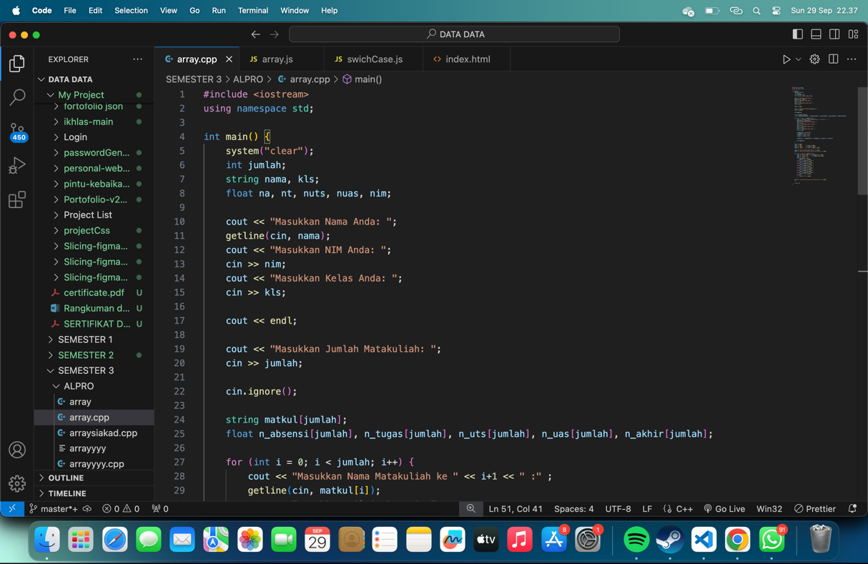

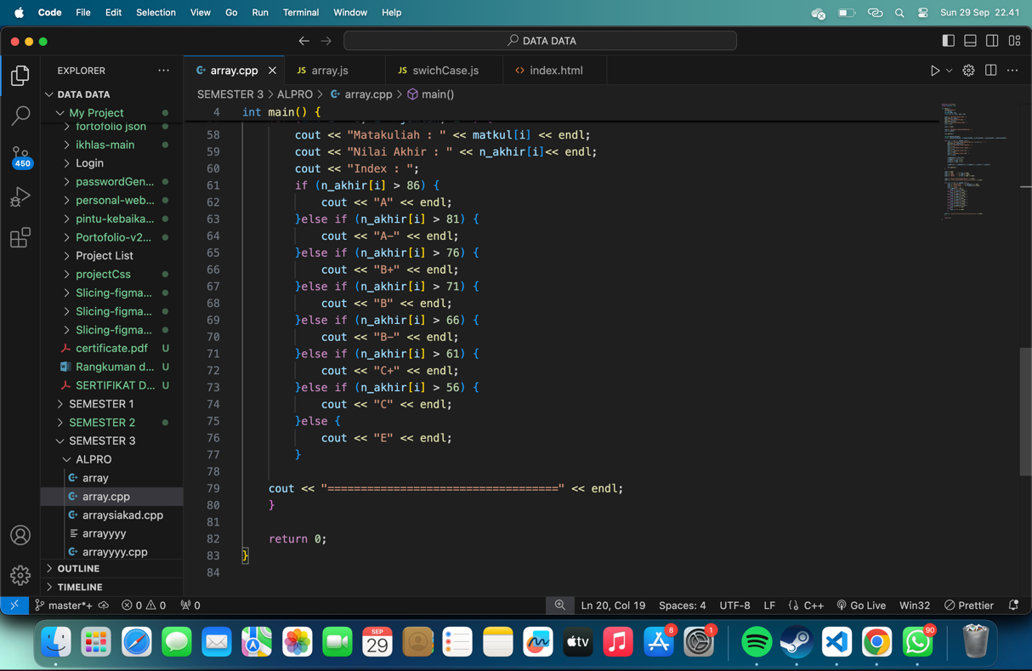

Top of Form

